# Configuration Settings

**Purpose**:

Imports data into configuration settings entity in CRM.

**Contents:**

1. Open the attached configuration settings file.



1. Fill the respective values for configuration key and save the file.
2. Once it is saved, open CRM instance in browser and navigate to Settings->Deployment->Configuration Settings.

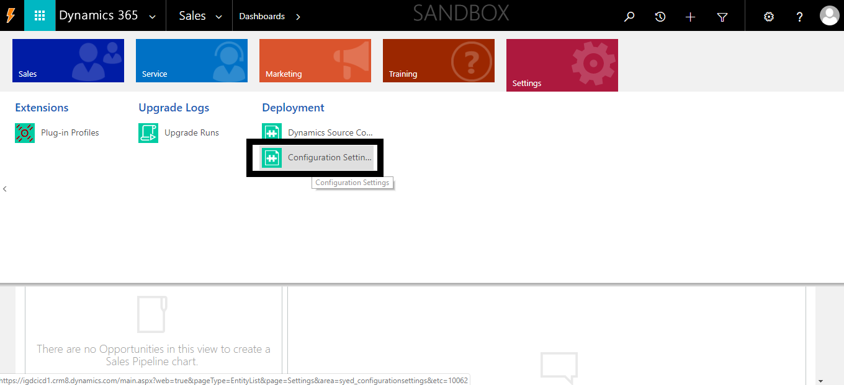

1. Active Configuration settings list gets opened.
2. Go to ribbon bar and select Import Data.

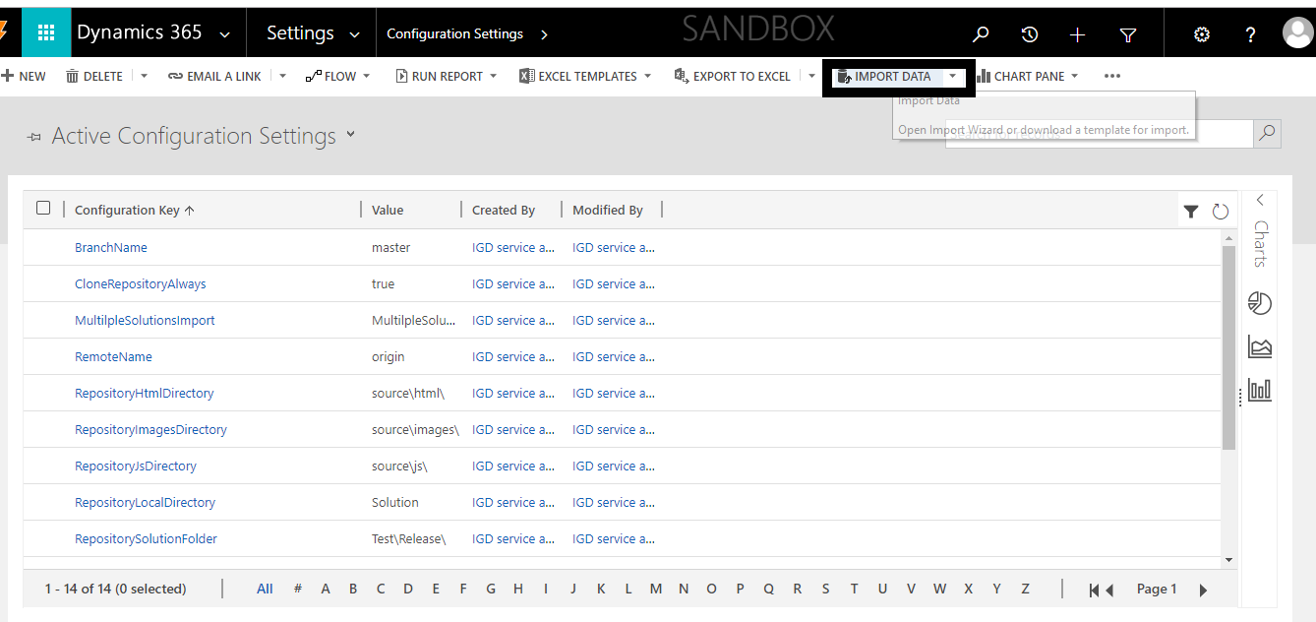

1. After clicking on import data upload data file wizard gets opened.

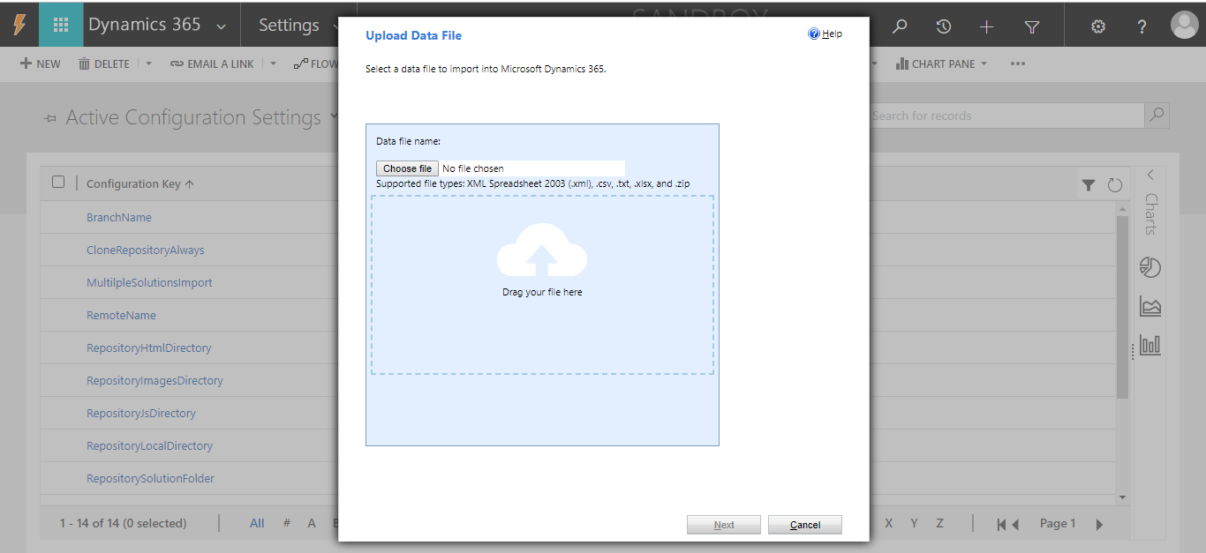

1. Select configuration settings excel file and click on Next.
2. Review Settings and Import Data screen appears where we can select “Allow duplicate” to be yes or no for duplicate records.

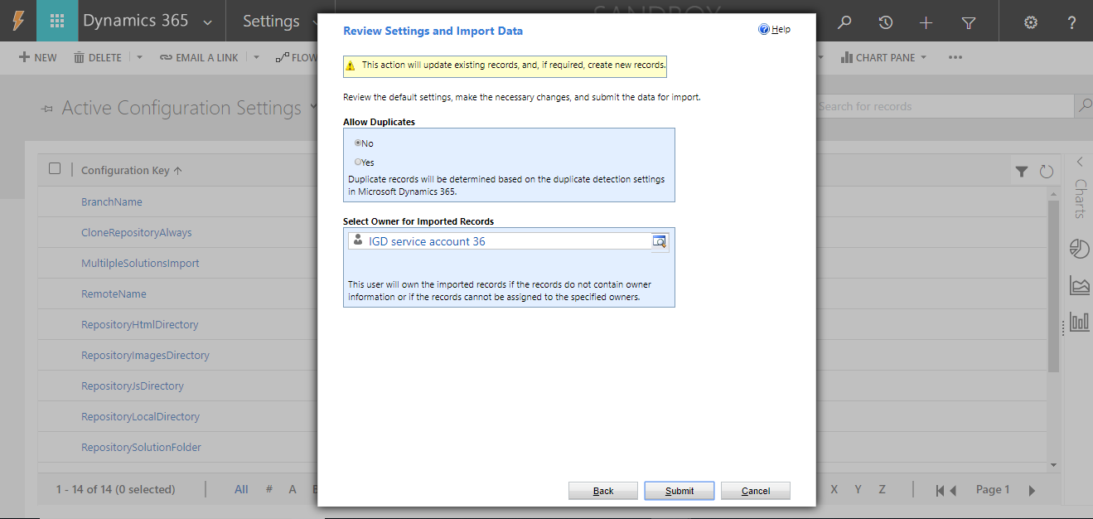

1. Click Submit.
2. Data Submitted report screen appears with status as submitted.

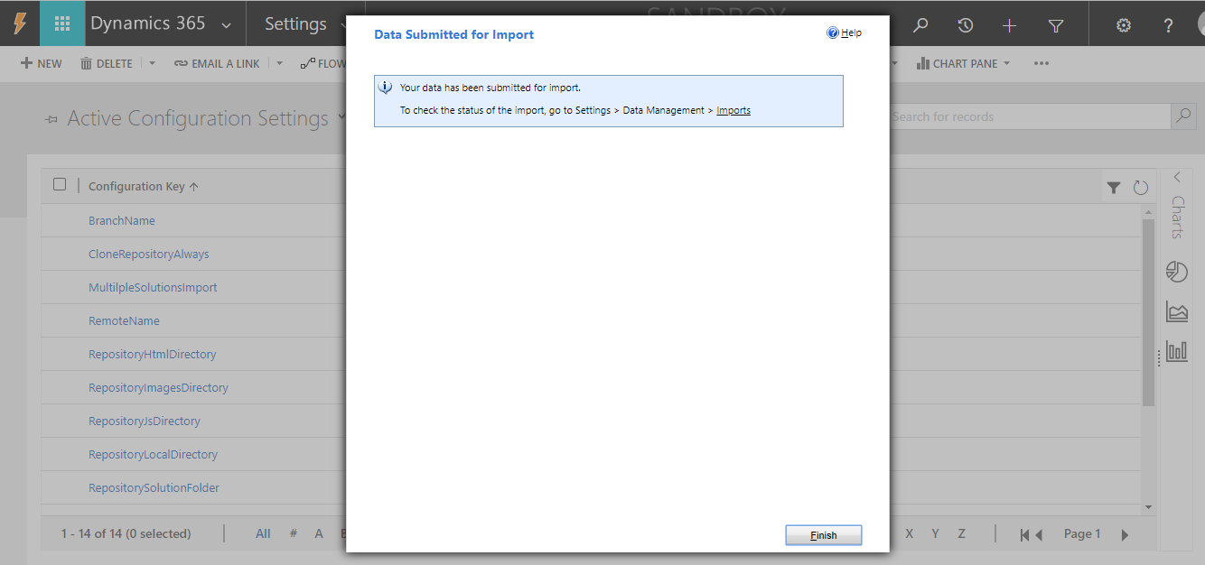

1. Click Finish to see imported data.
2. To check the status of import, navigate to Settings->Data Management->Imports

